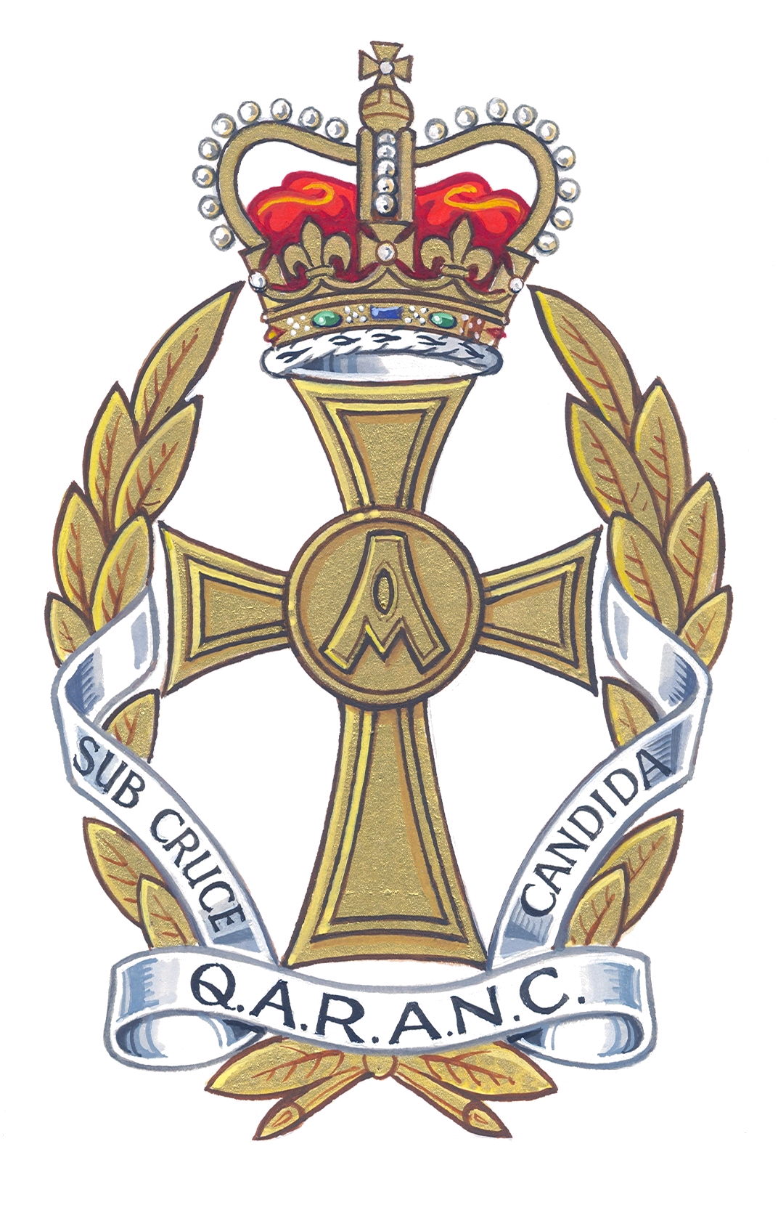


QUEEN ALEXANDRA’S
ROYAL ARMY NURSING CORPS ASSOCIATION

A charity registered in England and Wales – 270278

REGIMENTAL HEADQUARTERS QARANC
HQ AMS, Slim Road, Camberley, GU15 4NP

Tel: Civil: 01276 412754 Mil: 94261 2754
AO: Tel: Civil: 01276 412747 Mil: 94261 2747
Fax: Civil: 01276 412793 Mil: 94261 2793
e-mail: regtsecqaranc@hotmail.com

QARANC ASSOCIATION - MEMBERSHIP APPLICATION

Surname (Block capitals please) ……………………………….
Christian Names ……………………………. Maiden Name ………………….
Married/single/widow/widower …………… Date of Birth ……………
Rank ………… Service No …………… Decorations ……………..
Address ( Permanent address to which Gazette and all correspondence should be sent):
…………………………………………...
…………………………………………...
…………………………………………... Tel No …………………………
E-Mail Address……………………………………………………………...
QARANC/QARANC(V)/QAIMNS/QAIMNS(R)/TANS …………………………
Brief description of Service including dates: ………………………………………….
…………………………………………………………………………………………………………………………………………………………………………………………………………………………………………………………………………………………………………………………………………………………………………

Please forward a cheque for the first payment. For ease of administration future payment is preferred by Direct Debit. This will be deducted in January each year.
Please make cheques payable to the QARANC Association.
Annual Subscription including Gazette UK/N. IRELAND/ISLE OF MAN £12.00
Annual Subscription including Gazette EUROPE/EIRE £16.00
Annual Subscription including Gazette ALL OTHER DESTINATIONS £20.00
Association Brooch £5.00

Please state which branch you would like to join ……………….. or remain on HQ Roll.

Signature ……………………….. Date …………

